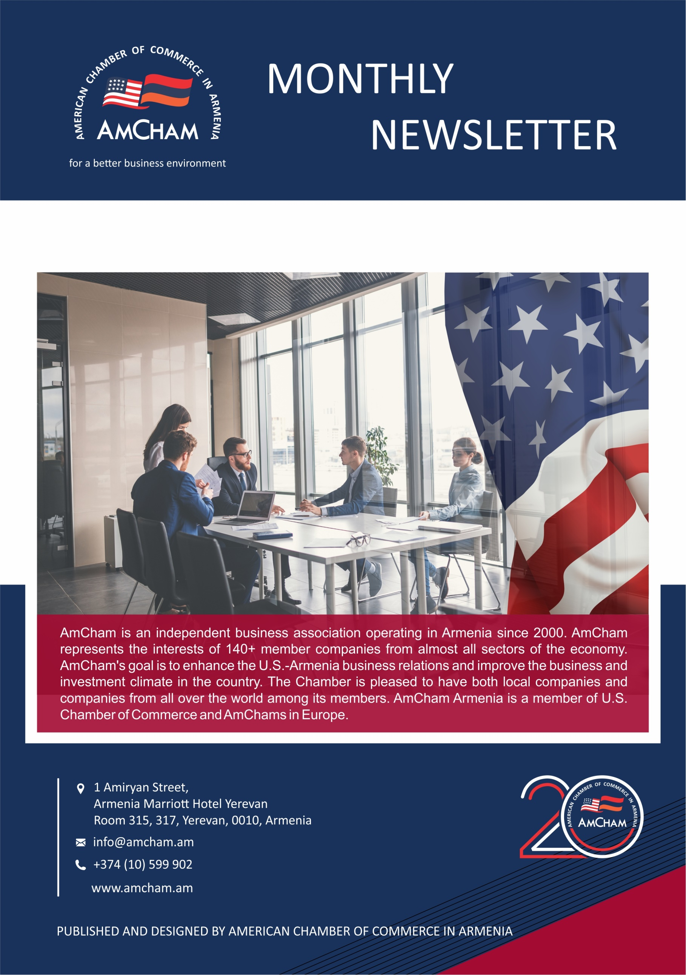

**June 2020**

**BUSINESS COMMUNITY AND SUSTAINABLE WASTE MANAGEMENT WEBINAR**

On 12 June 2020, the American Chamber of Commerce in Armenia Fast Moving Consumer Goods (FMCG) Committee Waste Management Working Group, the American University of Armenia (AUA) Acopian Center for the Environment European Business Association Armenia (EBA), and Union of Manufacturers and Business of Armenia (UMBA) jointly organized the Business Community and Sustainable Waste Management webinar.

The webinar is part of the initiative started by **AmCham’s FMCG Committee Waste Management Working Group**. The aim is to raise awareness and encourage the Armenian business community to meet its environmental obligations, including the EU-Armenia Comprehensive and Enhanced Partnership Agreement (CEPA). During the webinar, business chambers, industry representatives and international organizations discussed what the business community can do to promote a sustainable waste management agenda in Armenia and presented an action plan.

The webinar was facilitated by Ms. Karine Sarkissian, Executive Director, AmCham, who along with Mr. Alen Amirkhanian, Director, Acopian Center for the Environment, AUA welcomed the guests and introduced to the Agenda. Mr. Harutyun Alpetyan, Circular Economy Expert, Acopian Center for the Environment, AUA presented the RA legislation and management systems on the packaging and other business waste, such as Extended Producer Responsibility (EPR), voluntary-based systems, etc. Ms. Elina Markaryan, Vice President, AmCham, and Mr. Alexander Babaskin, Regulatory Affairs Manager, Coca-Cola HBC Business Unit, spoke about the business communities' approaches for sustainable waste management systems, the importance of raising awareness on those systems, and the Ukrainian experience. Mr. Alen Amirkhanian introduced to the Committee Waste Management Working Group plan, and the webinar was concluded with a question and answer session.

It was agreed to continue the cooperation between the business chambers, the business community, and the public sector. This was the 2nd event after October 2019, when the **AmCham Committee on Fast Moving Consumer Goods** organized an open discussion on the exchange of international experience on solid waste management, during which the leading experts presented the best experience for Armenia in creating a responsible business environment between the state and the private sector.

If you missed the webinar, please click [**here**](https://www.facebook.com/AmChaminArmenia/videos/723528545082427) for the event video recording.

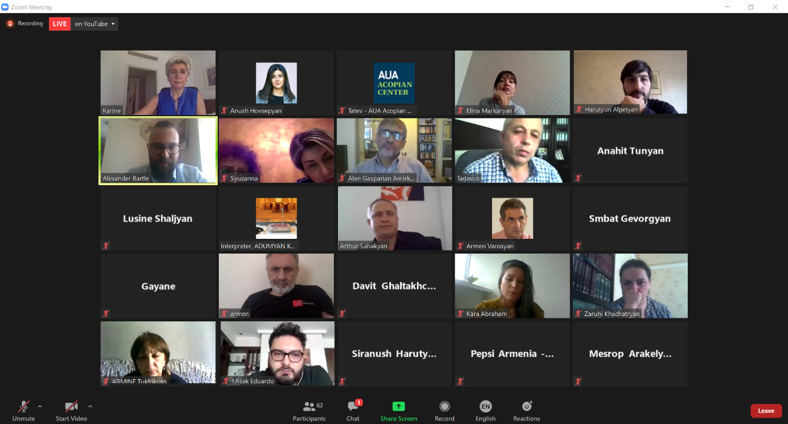



**TAX, CUSTOMS AND FISCAL POLICY – TCUFP COMMITTEE VIRTUAL MEETING**

**BUSINESS COMMUNITY AND SUSTAINABLE WASTE MANAGEMENT WEBINAR**

On 10 June 2020, AmCham in Armenia held its regular Tax, Customs, and Fiscal Policy – TCuFP Committee Virtual Meeting with Mr. Tatul Khudatyan, K&P Law Firm, on Confiscation of Property of Illegal Origin law implementation details.

As a result of the discussion AmCham Members and the AmCham Executive Team summarized that there is a gap in the implementation tools and it will create a confusion among the current business owners and potential investors, especially in the banking sector. Mr. Tatul Khudatyan suggested to prepare a recommendation paper on the implementation tools which was reviewed and discussed during the TCuFP meeting held on 24 June, 2020. It was agreed that a letter will be sent to the Ministry of Justice with a request on organizing a forum with all the relevant stakeholders to raise the concerns and get clarification.  
Members from various AmCham Member companies as well as Mr. Tatul Khudatyan, K&P Law Firm, participated in the meeting. Mr. Aharon Levonyan, Seraphim Consulting, and Ms. Irina Dumanyan, Mentor Graphics a Siemens Business, Director of AmCham Board, Mr. Nerses Nersisyan, KPMG Armenia, Mr. Suren S. Ghalumyan, Deloitte Armenia, Mr. Karen Zakaryan, FINARM - Financial Market Members Association, Ms. Lilit Gevorgyan, PMI Armenia, Ms. Lusine Mnatsakanyan, Coca-Cola HBC.

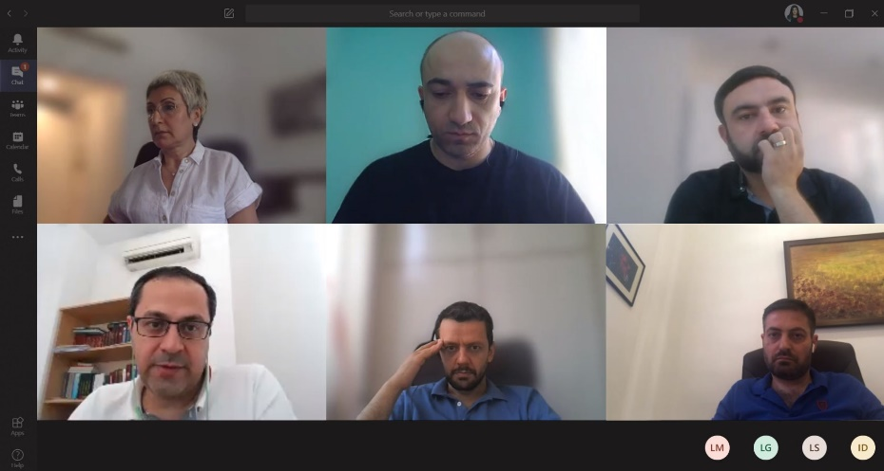

**DID YOU KNOW?**

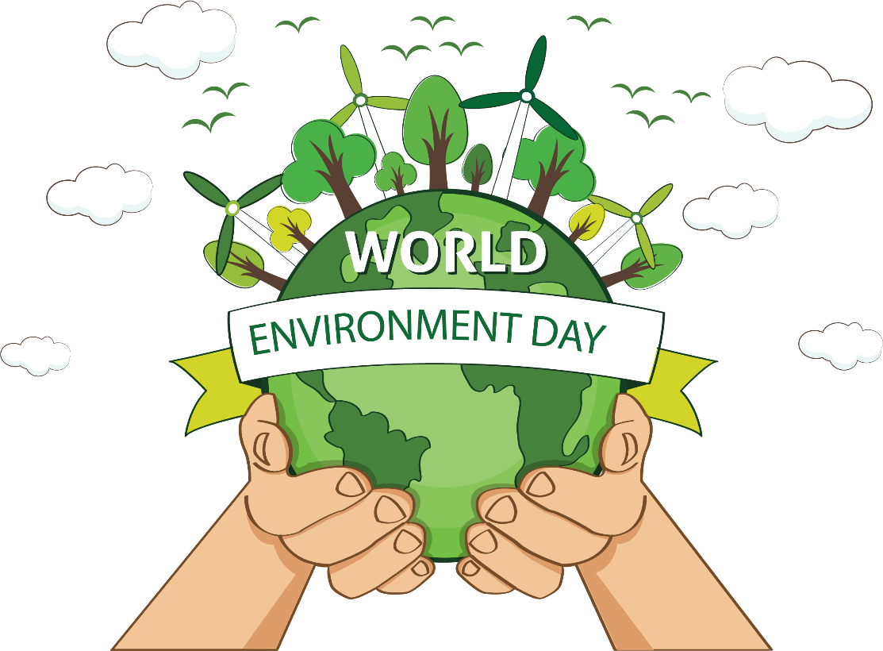

**World Environment Day**

“The greatest threat to our planet is the belief that someone else will save it.” The words of Robert Swan, a British author, are widely known to remind everyone that the future of our environment depends on our actions.   
Starting from 1974, annually on June 5, the world celebrates the Day of Environment, Issued by the United Nations. World Environment Day engages governments, businesses, celebrities and citizens to focus their efforts on raising awareness on environmental issues such as marine pollution, global warming, human overpopulation, and so on. Each year, WED has provided a new theme that major corporations, NGOs, communities, governments and all celebrities worldwide adopt to advocate environmental causes.

This year’s theme for the WED celebration was “Biodiversity” with a focus on its role as the foundation that supports all life on land and below water. This year the EU and UNDP in Armenia invited young Armenians to take part in the poster contest “Time #ForNarture” for encouraging worldwide awareness and action to protect our environment. Two winners received a travel pack, containing a number of attractive gifts.   
The Opening video is available [here](https://www.youtube.com/watch?time_continue=915&v=4h5AY6quYYY&feature=emb_logo).



**TAX, CUSTOMS AND FISCAL POLICY – TCUFP COMMITTEE VIRTUAL MEETING**

On 24 June 2020, AmCham held its regular Tax, Customs, and Fiscal Policy – TCuFP Committee Virtual Meeting. During the meeting AmCham Members and the AmCham Executive Team discussed:

• Recommendation Paper on Confiscation of Property of Illegal Origin law and implementation details

It was decided during the meeting that a meeting should be organized with the Ministry of Justice and with the General Prosecutor's Office in the near future in order to discuss the Law Implication details and the general guidelines.

Members from various AmCham companies as well as Mr. Tatul Khudatyan, K&P Law Firm, participated in the meeting and presented his point of view.

Ms. Irina Dumanyan, Mentor Graphics a Siemens Business and, who also represents AmCham Board of Directors, Mr. Nerses Nersisyan, KPMG Armenia, Mr. Kamo Karapetyan, EY, Mr. Suren S. Ghalumyan, Deloitte Armenia, Mr. Karen Zakaryan, FINARM - Financial Market Members Association, Ms. Lusine Mnatsakanyan, CCHBC.

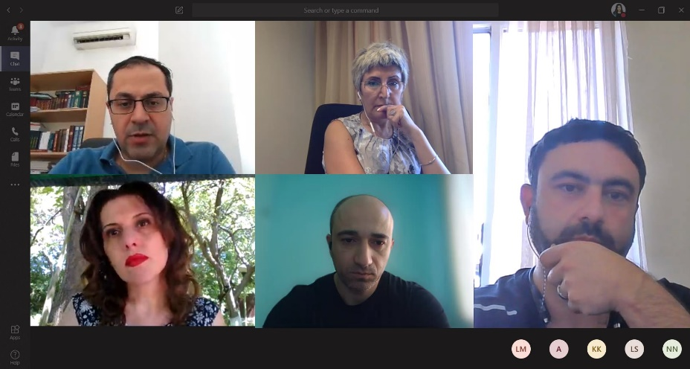

**FAST MOVING CONSUMER GOODS – FMCG COMMITTEE VIRTUAL MEETING**

On 24 June 2020, AmCham held its regular Fast Moving Consumer Goods – FMCG Committee Virtual Meeting. During the meeting, AmCham Members, AmCham Partners – the American University of Armenia (AUA) Acopian Center for the Environment and Union of Manufacturers and Business of Armenia (UMBA) discussed:

1. The Pager on **Waste Management mechanisms implementation in Armenia** to encourage the Armenian business community to join the efforts in establishing transparent, effective and sustainable packaging waste collection and recovery system in order to meet its environmental obligations,

2. Planning and structure of the One to One calls,

3. MOU among partners to be implemented.

AmCham Members, Partners, and Executive Team participated in the meeting:

Mr. Alen Amirkhanian, AUA Acopian Center for the Environment, Ms. Syuzanna Hayrapetyan, UMBA, Ms. Susanna Hayrapetyan, Ms. Anahit Tunyan, CCHBC.

Plse insert hthe pager

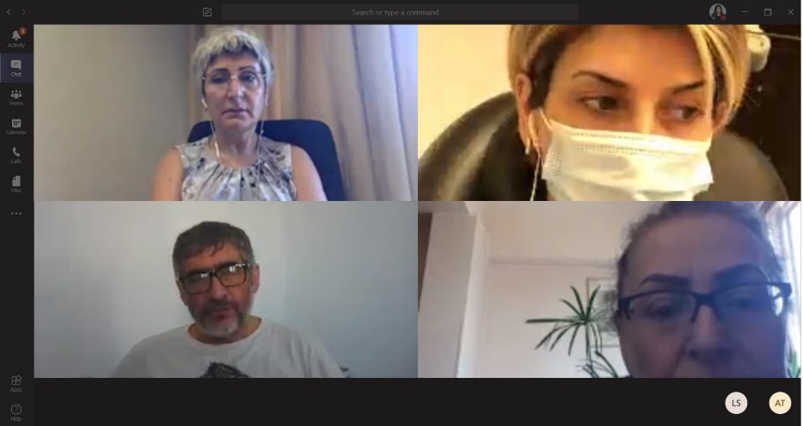



**EXTENDED PRODUCER RESPONSIBILITY (EPR) PAGER**

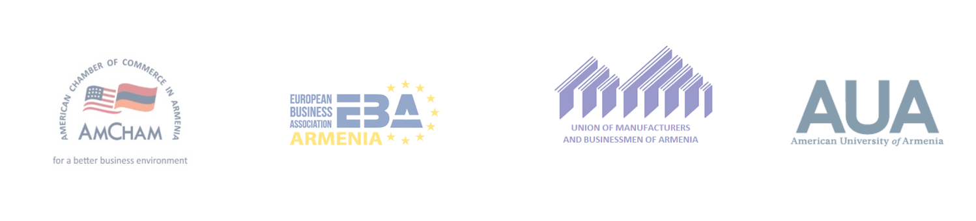

Armenian Business Community

**Take the lead and make your voice heard in the upcoming changes!**

With this letter, we encourage the Armenian business community to join the efforts in establishing transparent, efficient, and sustainable post-consumer waste management system to meet Armenia’s obligations to introduce **Extended Producer Responsibility (EPR) system by 2023**. This commitment is part of the EU-Armenia Comprehensive and Enhanced Partnership Agreement (CEPA) signed between EU and RA of Armenia in 2017 կազմում: *

While Nature Protection Payments (Բնապահպանական վճարներ) aim to mitigate the damages caused to the environment, the **Extended Producer Responsibility** system ensures the proper handling of specific post-consumer waste products (tires, batteries, packaging, etc.) that producers or importers have put in the market.

The models of Extended Producer Responsibility vary from country to country, and **Armenia is yet to develop and adopt the best working model that would meet its environmental and economic needs**. **The global practice shows that the earlier the businesses engage in the initial stages of the strategy development, the better model the country adopts.** While the RA Government is obliged to create the necessary legislative framework, the role of the private sector is to support this process through the following:

* Engage in a dialogue with the government and follow up on policy development,
* Co-finance the research/study of various scenarios for the introduction of an Extended Producer Responsibility (EPR) in Armenia and the development of an appropriate model according to international experience.

**It is important that the private sector will take an active role in helping to create the best recycling system in the country.**

Municipal **Post consumption waste** (PCW) management is in a development stage in Armenia and we as a business community need to produce data and evidence on deciding the best case scenario to increase packaging waste recycling in the most effective and efficient way to create a win-win scenario that will meet compliance targets and at the same time mitigate potential tax implications on business.

Together, we need to conduct research/study through a professional agency for the following purposes:

* Analyze the current PCW situation, specifically volumes, types, collectors, recyclers, and opportunities; run SWOT to decide on the best waste collection and recycling practices, from the available alternatives, which will be the most suitable for Armenia and financially justified.
* Develop the best case implementation plan/guidance scenario for taking actions with the best expert agency.
* To engage with the government and negotiate the best case scenario of collaboration to drive the agenda and support the business interests.

**Join the initiative!**

**American University of Armenia (AUA)**

**American Chamber of Commerce of Armenia (AmCham) Fast Moving Consumer Goods (FMCG) Committee**

**Waste Management Working Group**

**European Business Association Armenia (EBA)**

**Union of Manufactures and Business of Armenia (UMBA)**

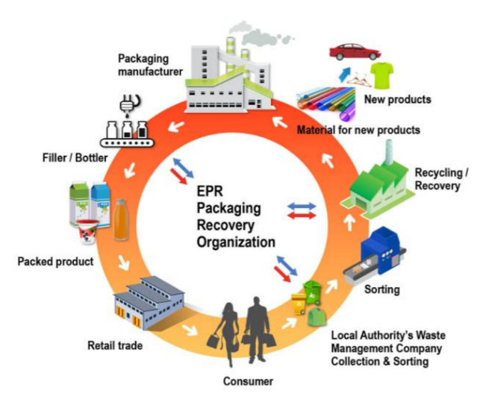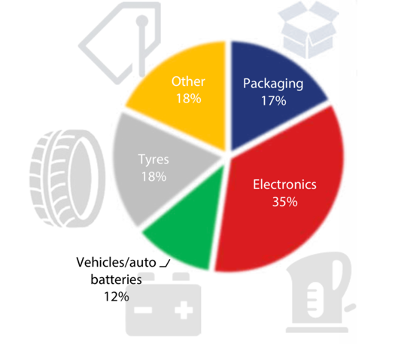



**EXTENDED PRODUCER RESPONSIBILITY (EPR) PAGER**



**Q&A**

**Question․ What are the start and end dates of the research?**

**Answer**․ The dates will be determined when the number of organizations interested in the initiatives is confirmed. The study process is planned to start in September 2020. Before starting the study, a tender will be announced with detailed Terms of Reference. The best agency selection criteria will be based on the the best technical implementation experience and price.

**Question․ Which organization will conduct the research and how will it be selected?**

**Answer․** Even though there are experienced organizations, the selection will follow the tender procedure – preparation of Terms of Reference, announcement for tender, receiving applications and selection.

**Question․ What is the purpose of the research and what will be the result.**

**Answer․** As a result of the research, the best waste management model for both the public and private sectors will be selected. The model will be justified by financial and economic analysis based on the current situation in Armenia.

**Question․ Which level specialist form an organization shall be involed?**

**Answer․** The organization should provide the contact details of a technical manager who is involved in waste management and environmental issues. However, the process must be under the general director’s supervision.

**TAX, CUSTOMS AND FISCAL POLICY – TCUFP COMMITTEE VIRTUAL MEETING**

On 4 June 2020, AmCham in Armenia held its regular **Tax, Customs, and Fiscal Policy – TCuFP Committee Virtual Meeting**. During the meeting AmCham Members and the AmCham Executive Team discussed the **Proposal on the Property Taxation System Improvement in the Republic of Armenia by the Ministry of Finance Revenue Policy Improvement Council.** The Council introduced the Property Taxation changes on apartments, houses, etc. and the best scenario which was preferable for the government, and was planned to be implemented from 2021, throughout 4 years’ period. After the public discussion and before the adoption the Proposal will be discussed at the National Assembly.

The Property Taxation System Improvement Project will be resolving 2 main objectives:

• To increase the 0.2% Property (real estate) Tax contribution to the GDP to 0.8% , whereas the average is 1 %,

• To Introduce a Progressive Taxation Model vs. the Even Taxation model.

The proceeds from the Property Tax will be used to develop and empower the local government authorities in Armenia.

Mr. Aharon Levonyan, Seraphim Consulting, and Ms. Irina Dumanyan, Mentor Graphics a Siemens Business, who also represent AmCham Board of Directors, Mr. Nerses Nersisyan, KPMG Armenia, Mr. Suren S. Ghalumyan, Deloitte Armenia, Mr. Karen Zakaryan, FINARM - Financial Market Members Association, Ms. Lilit Gevorgyan, PMI Armenia, Ms. Lusine Mnatsakanyan, CCHBC.



**ARCHIDUTCH ARMENIA IN BIM PROJECT IN AMSTERDAM**

Since the opening of ArchiDutch LLC in Vanadzor in October 2018, the company has grown rapidly and now also has a branch in Yerevan. From here we work on various Dutch BIM projects.  We are very proud of one of these projects, therefore we would like to bring this to your attention: De Stelling.

De Stelling project contains 450 homes in total. The eye-catcher is the residential tower “De Heldin”, meaning the female hero. The tower will be 57 meters high, with 150 apartments on 17 floors.

The tower and the rest of the building is part of the future skyline of the city Zaandam, 8 km North of Amsterdam, and part of the Metropolitan Region Amsterdam.

The reasons to build these projects in the Metropolitan Region Amsterdam are:

* There is an urgent need for housing in all segments within the region.
* An urgent need for affordable rental houses and affordable houses for sale.

Therefore, the amount of 450 apartments and 350 m2 of shopping malls follow the demand of the region to deliver more affordable housing.

ArchiDutch LLC is asked to collaborate with the architect in modeling and engineering.

The modeling and engineering have 2 purposes. First, to get a building permit and second, to get the sheets and data on behalf of the contractor.

We are designing the following the three stages:

* Building permit drawings.
* Technical design, which needs to be ready by mid-August 2020.
* Completing design, by mid-September 2020.

It’s not just creating an Autodesk Revit model, but it’s a kind of smart modeling, so all the data needed on behalf of the department work preparation and calculation is placed inside the model. The data is connected with BIM360 Design and a Microsoft Excel database. Examples of data are the square meter brickwork and square meter concrete floors. Both the Building permit drawings as well as the structural drawings needed at the construction site are placed and drawn in the model.

The construction costs are approximately € 85 Mio or 47,000 bn AMD in total. 7 People, 2 in The Netherlands and 5 in Armenia, will work for about 1,750 hours in total on this project. Our offices in the Netherlands and Armenia are working together as one through Microsoft Teams and BIM360 Design.

With the digital innovation, cloud services, and technological developments, working globally is not an issue any more. This ensures that all of our teams can deliver on a high standard.

